WEEK 9 – LAB TASK ANSWERS (FOR WORD DOCUMENT)

Task 1: Load CIFAR-10 Dataset and Report Image Shape
The CIFAR-10 dataset was loaded successfully using TensorFlow. It contains 60,000 RGB images divided into 10 classes.

Image Shape
- Training Images Shape: (50000, 32, 32, 3)
- Testing Images Shape: (10000, 32, 32, 3)
- Single Image Shape: (32, 32, 3)

Explanation
The image dimensions are 32×32 pixels and contain 3 color channels (Red, Green, Blue). The dataset is commonly used for image classification tasks.

Task 2: Normalize Images and Explain Why Normalization is Important
The images were normalized by dividing pixel values by 255.

Why Normalization is Important
Normalization converts pixel values from the range 0–255 to the range 0–1.

Advantages
- Improves training stability.
- Speeds up convergence.
- Prevents large values from dominating learning.
- Improves model accuracy.
- Helps the optimizer perform efficiently.

Conclusion
Normalization is an important preprocessing step that allows the CNN to learn more effectively and produce better results.

Task 4: Explain Purpose of Filters and Kernels

Filters
Filters are feature detectors used in convolution layers.
Different filters learn different image characteristics such as:
- Edges
- Corners
- Curves
- Textures
- Shapes
For example, 32 filters allow the CNN to learn 32 different image features.

Kernels
A kernel is a small matrix that slides across an image to perform convolution operations.
Common kernel sizes include:
- 3×3
- 5×5
- 7×7

Purpose of Kernels
- Detect local patterns in images.
- Extract useful image information.
- Help CNN identify objects and structures.

Conclusion
Filters and kernels work together to extract meaningful features from images, enabling accurate image classification.

Task 10: Identify Signs of Overfitting from Graphs

Signs of Overfitting
- Training accuracy continues increasing.
- Validation accuracy stops increasing or decreases.
- Training loss decreases continuously.
- Validation loss begins to increase.

Example
If training accuracy reaches 98% while validation accuracy remains around 75%, the model is likely overfitting.

Why Overfitting Occurs
Overfitting occurs when the model memorizes training data instead of learning general patterns that can be applied to unseen data.

Conclusion
Overfitting reduces the model's ability to perform well on new data and can be identified by analyzing accuracy and loss graphs.

OUTPUTS OF CODES:

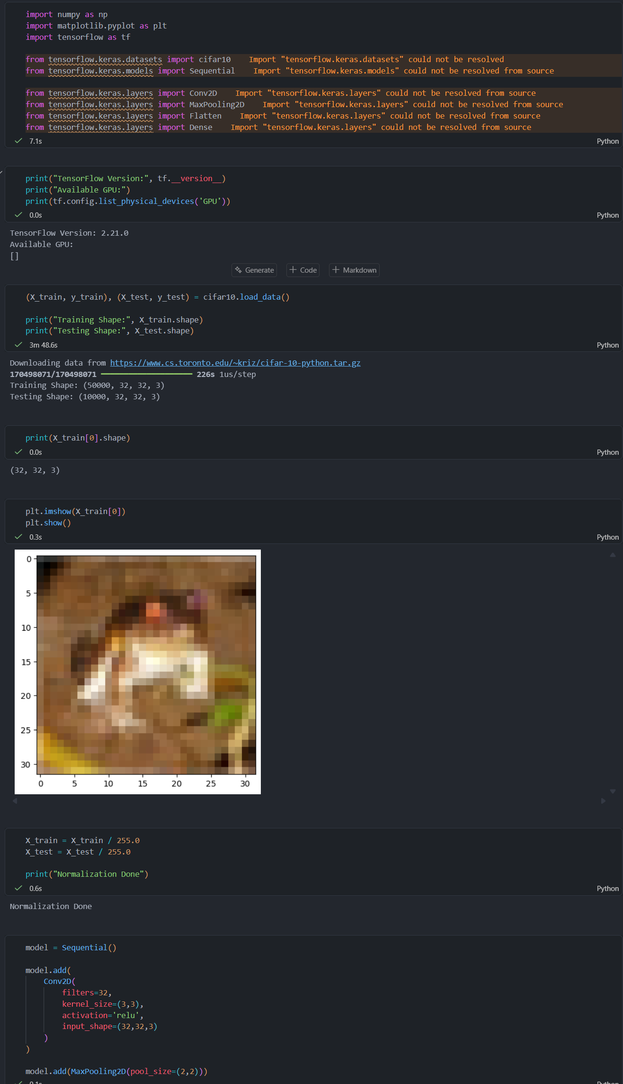
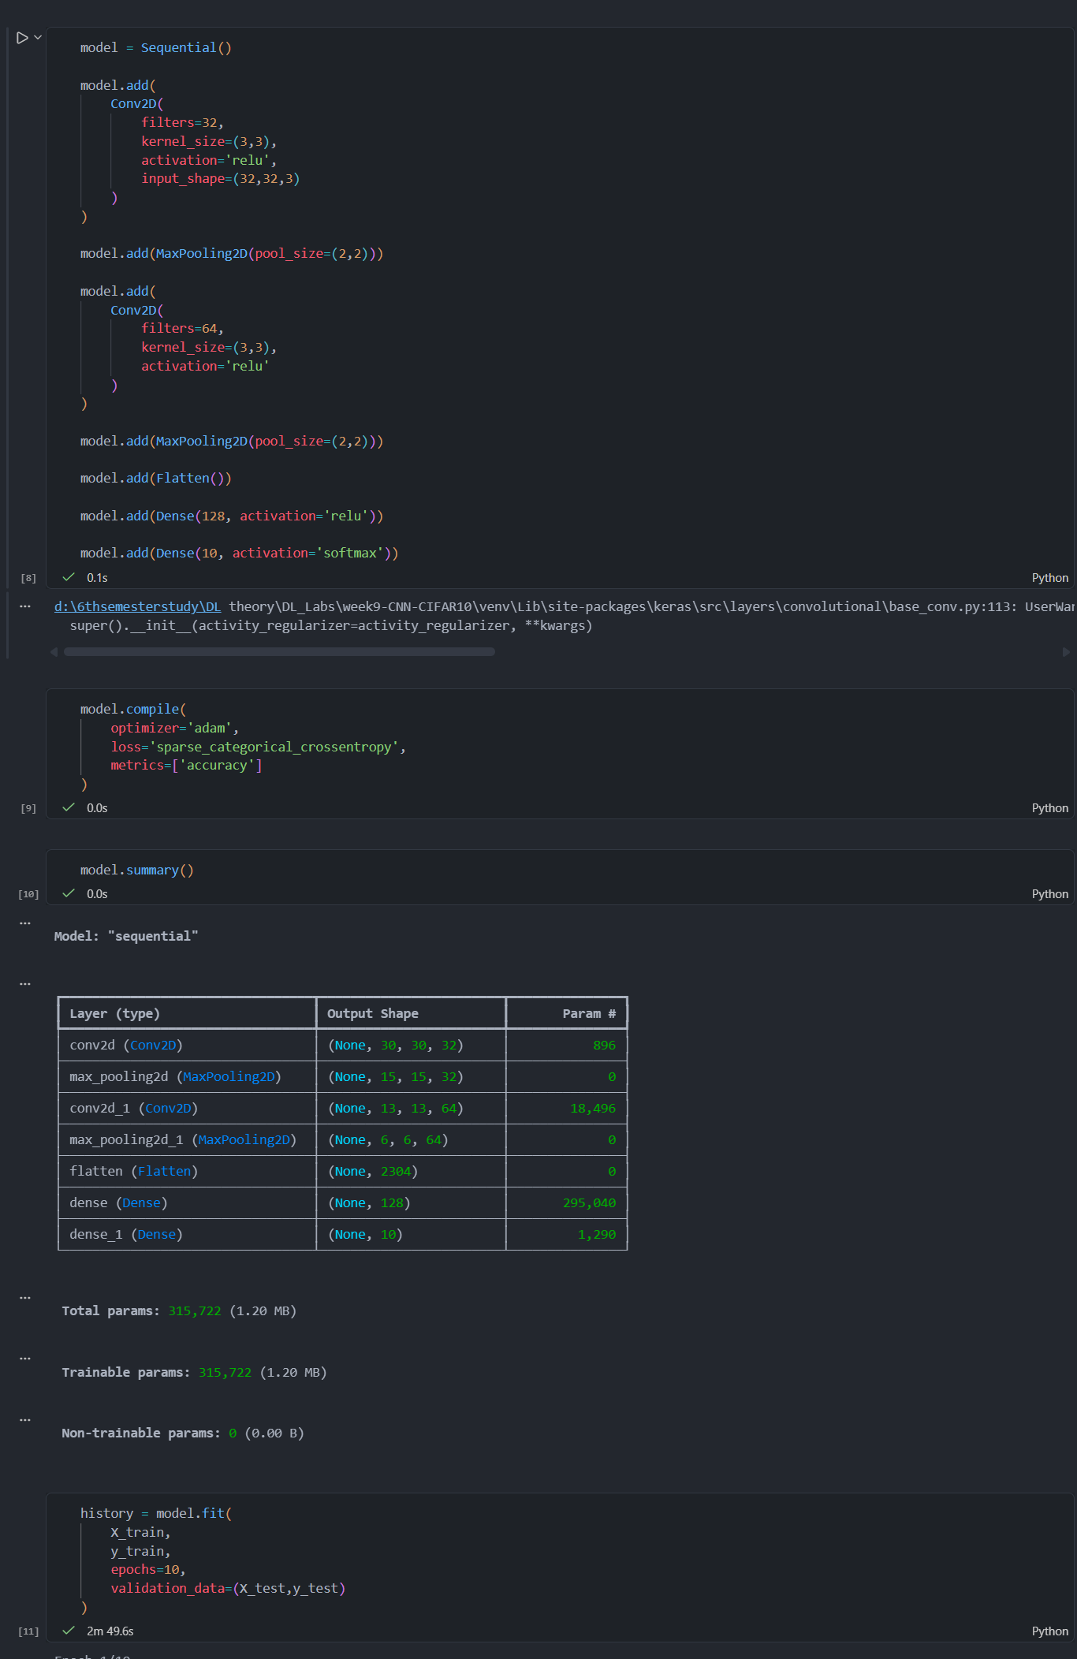
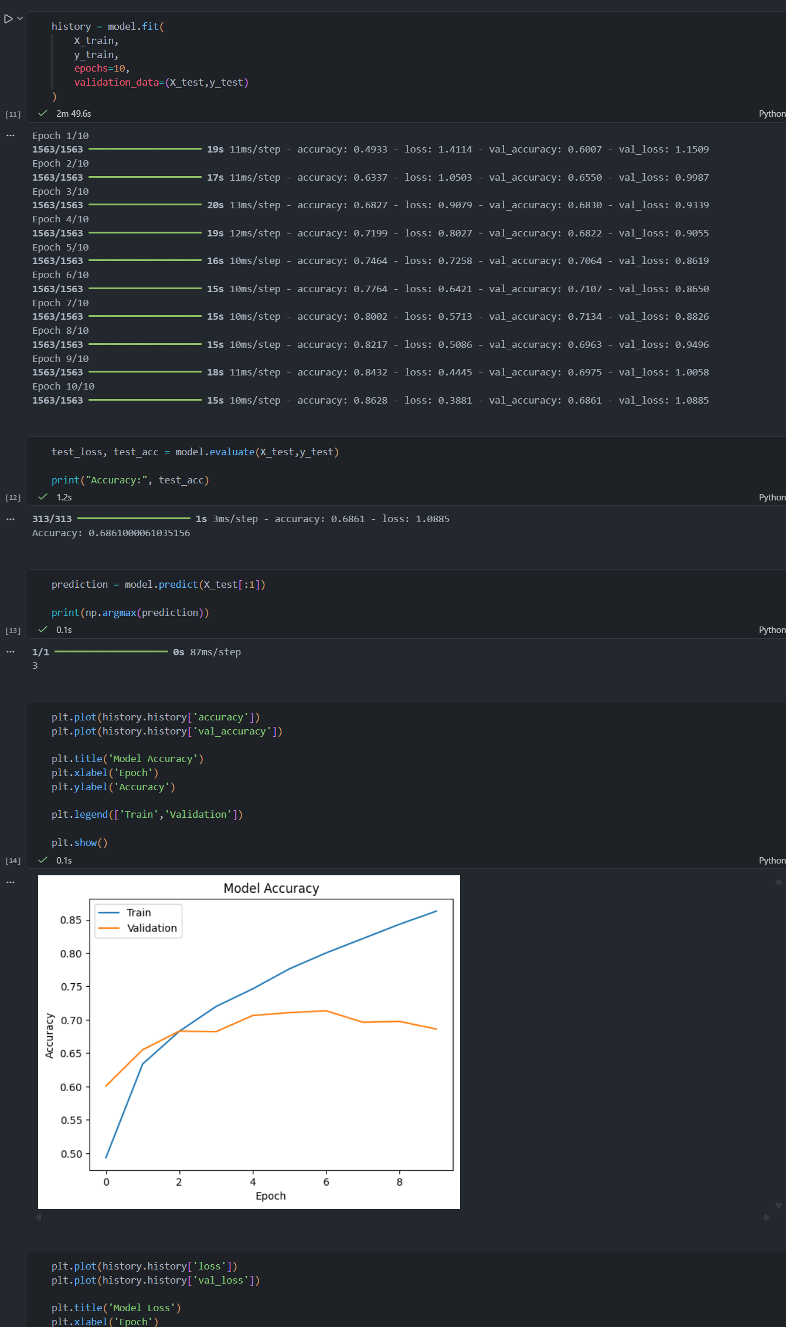
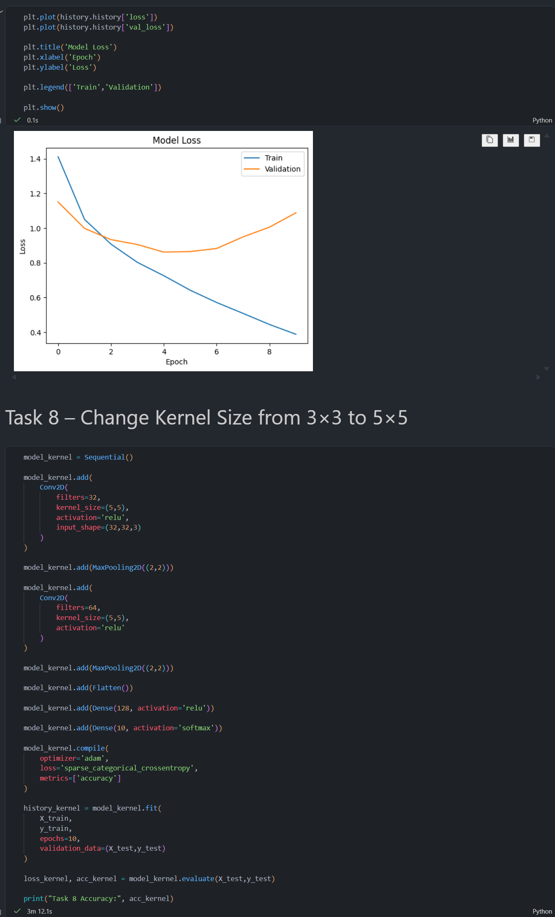
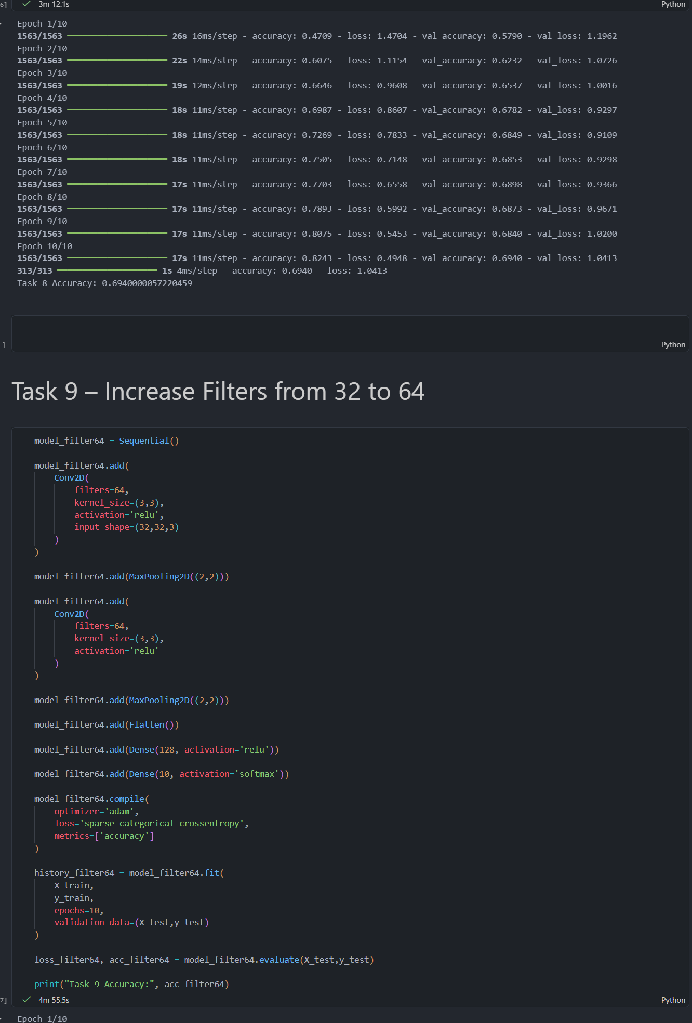
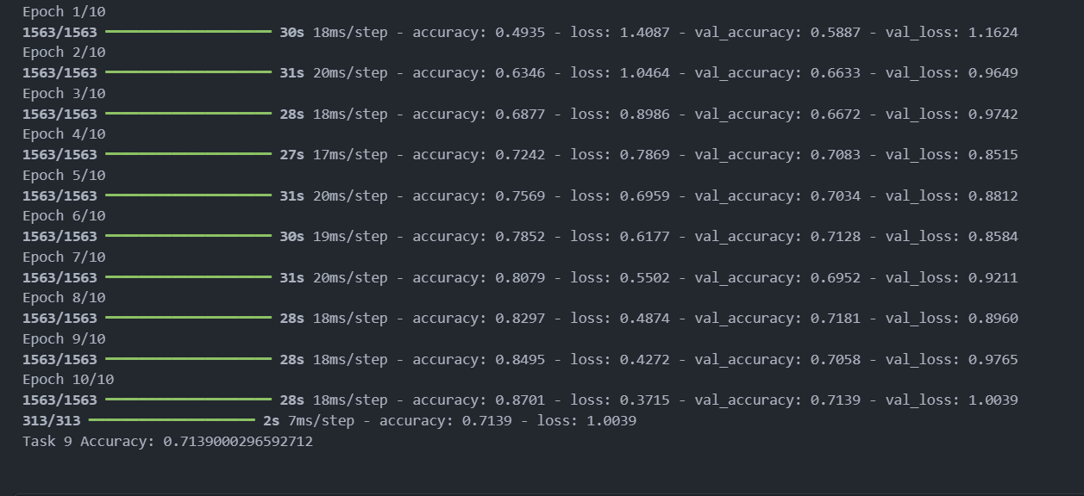
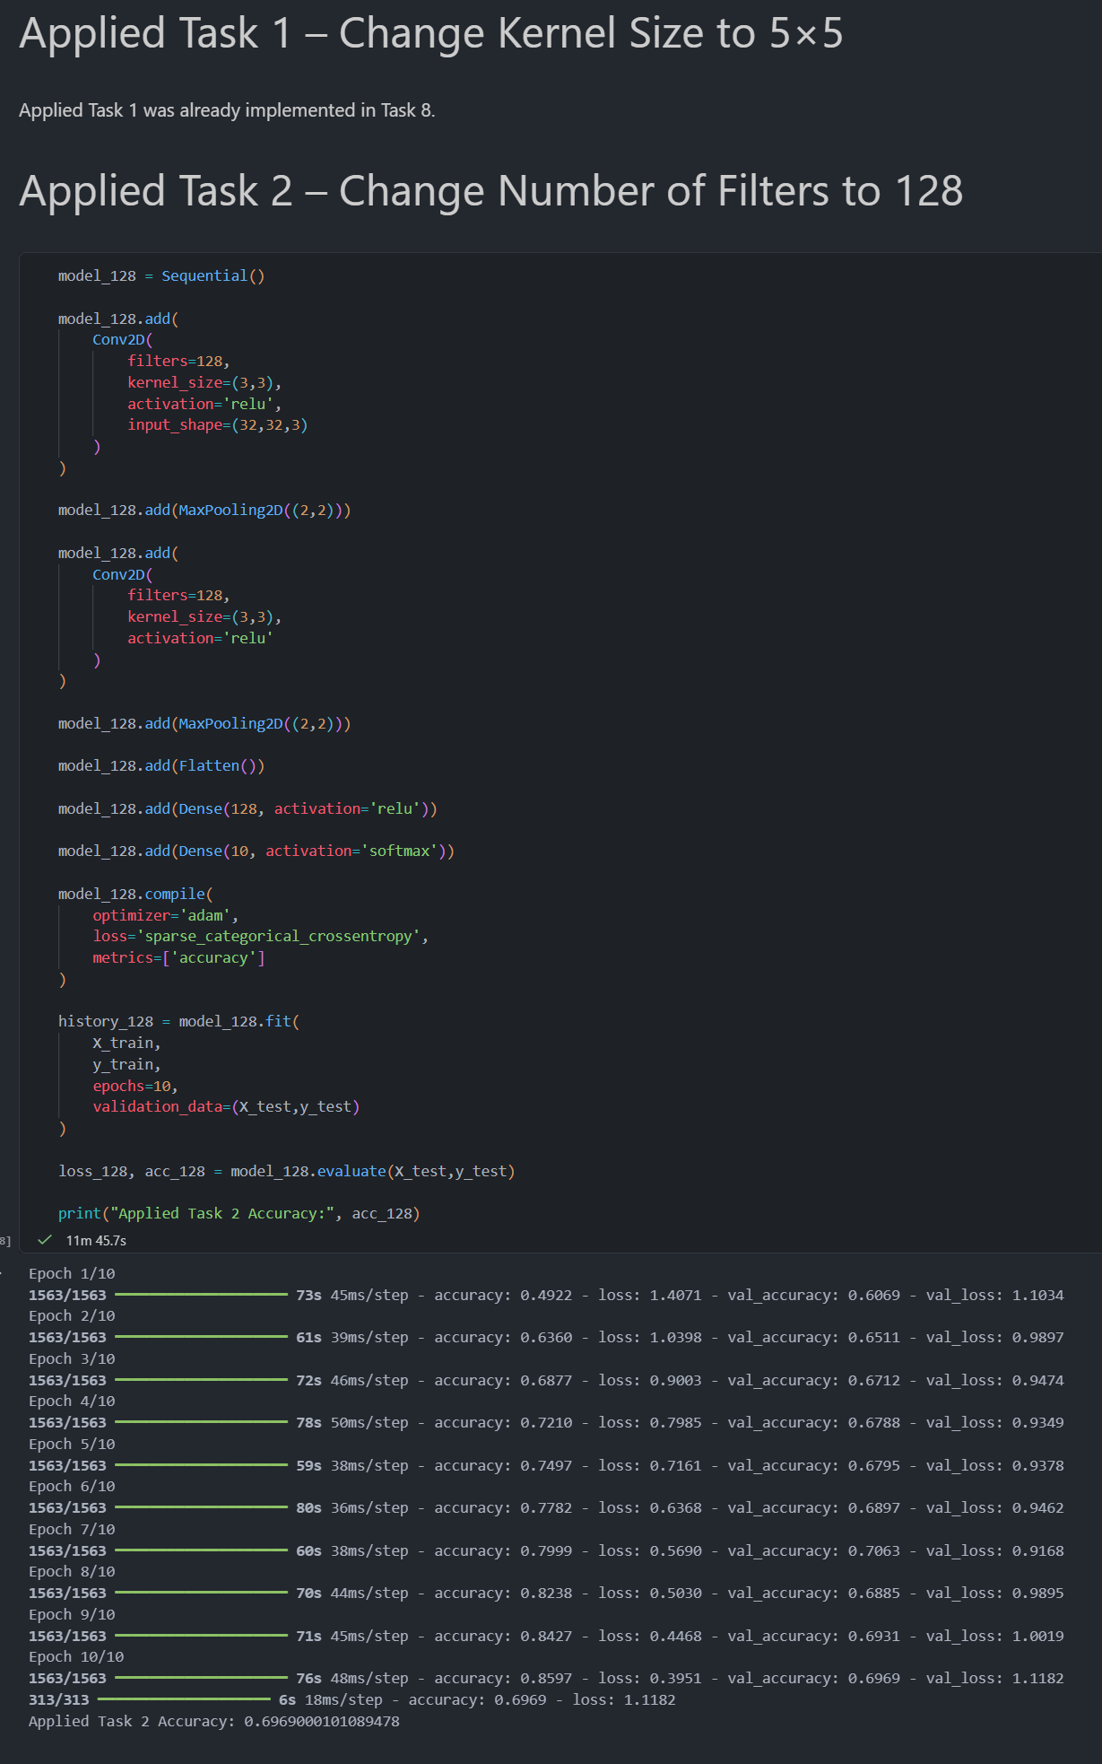
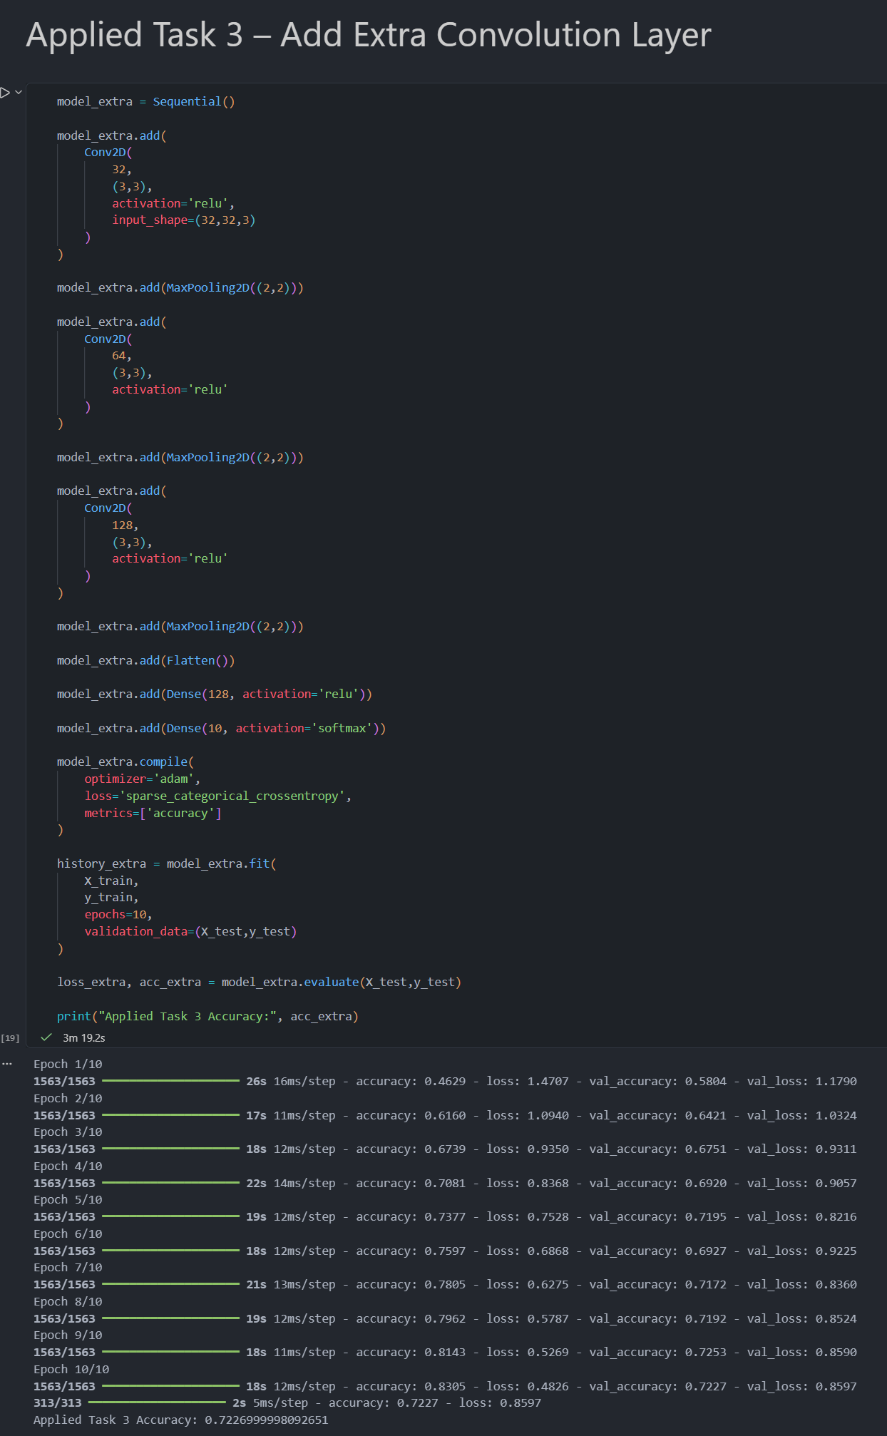
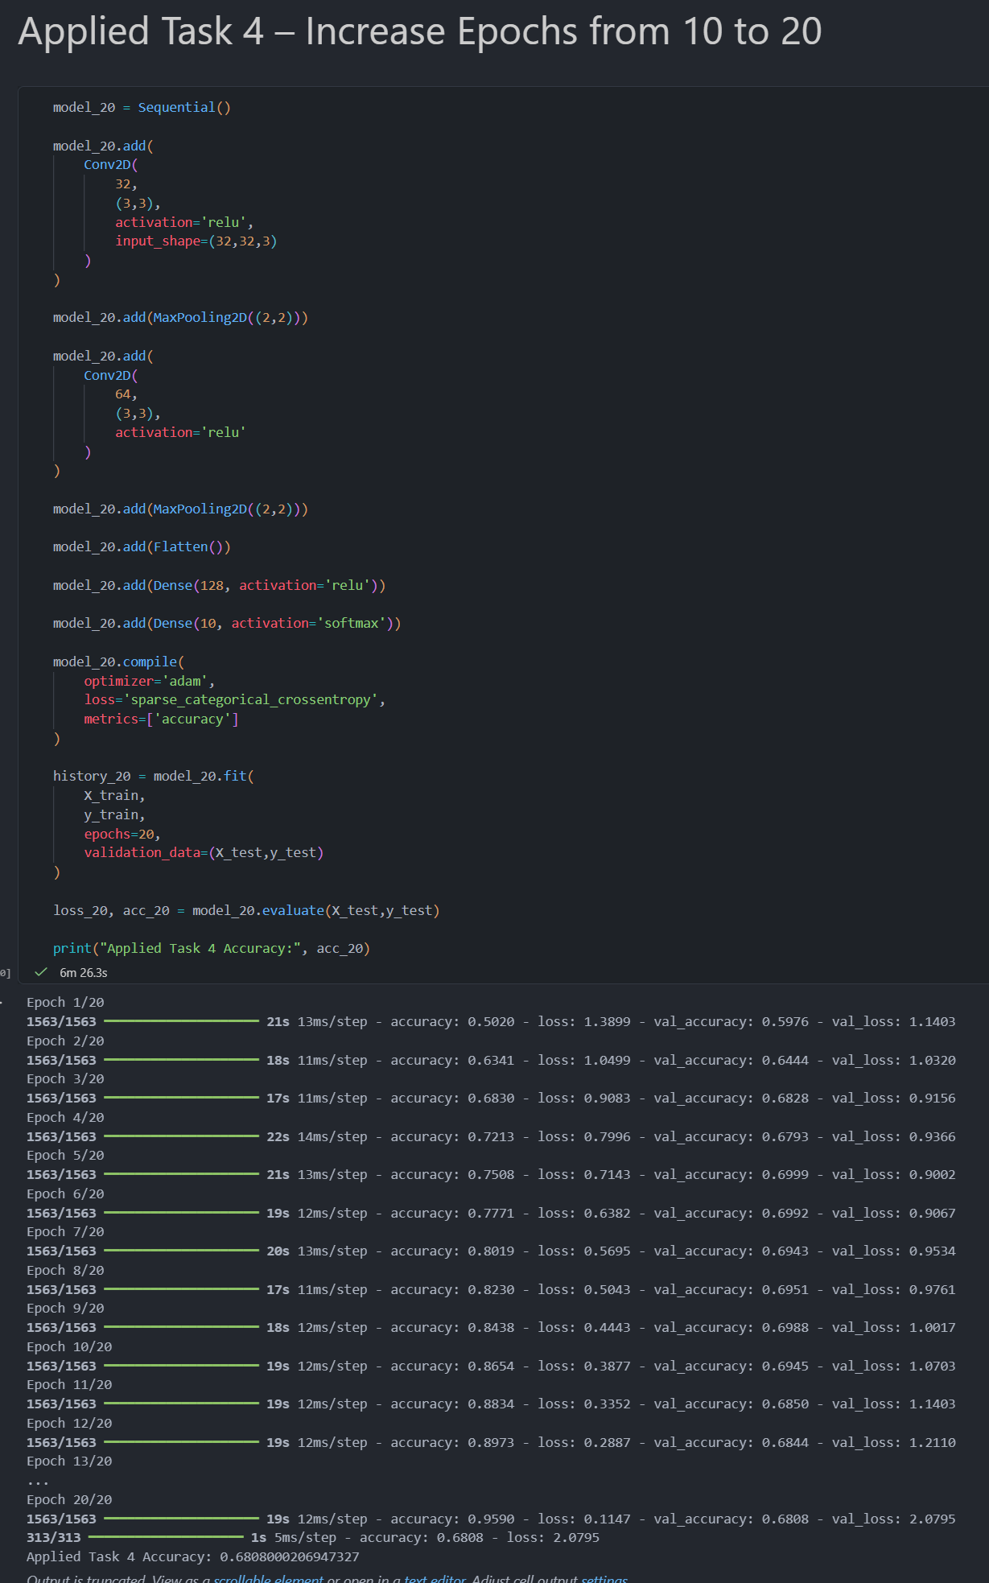
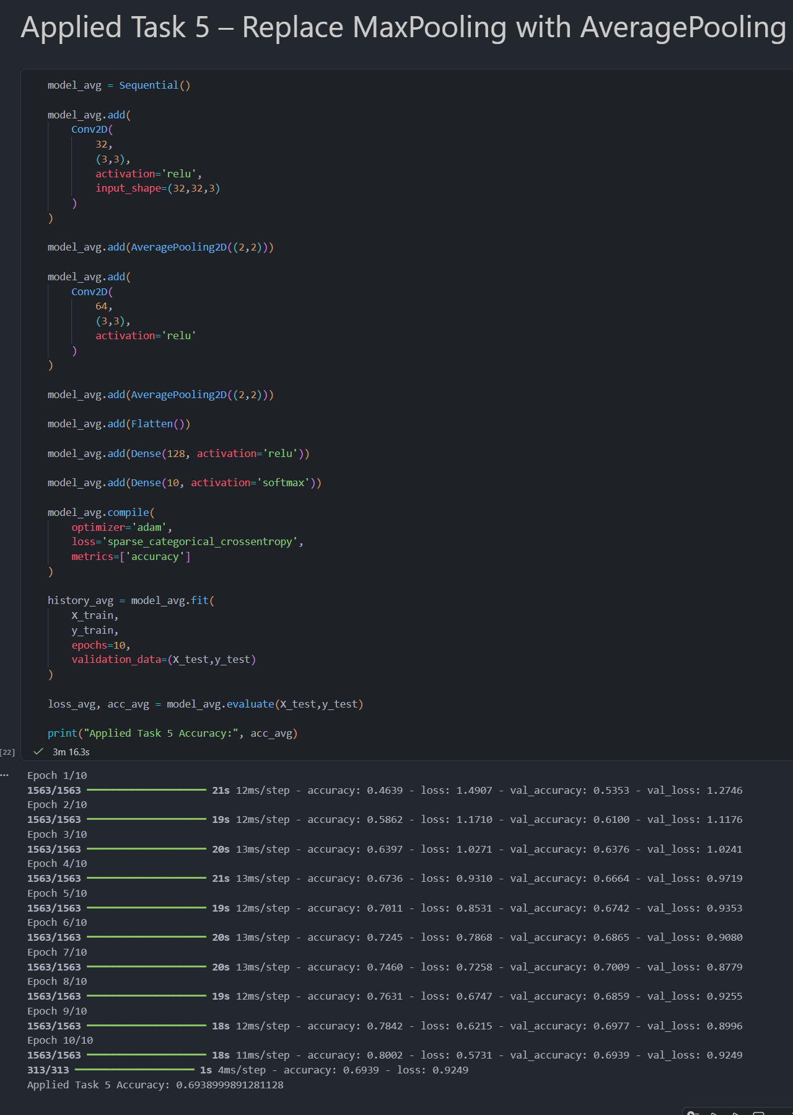

Final Comaprison:
